***Welcome to the course!***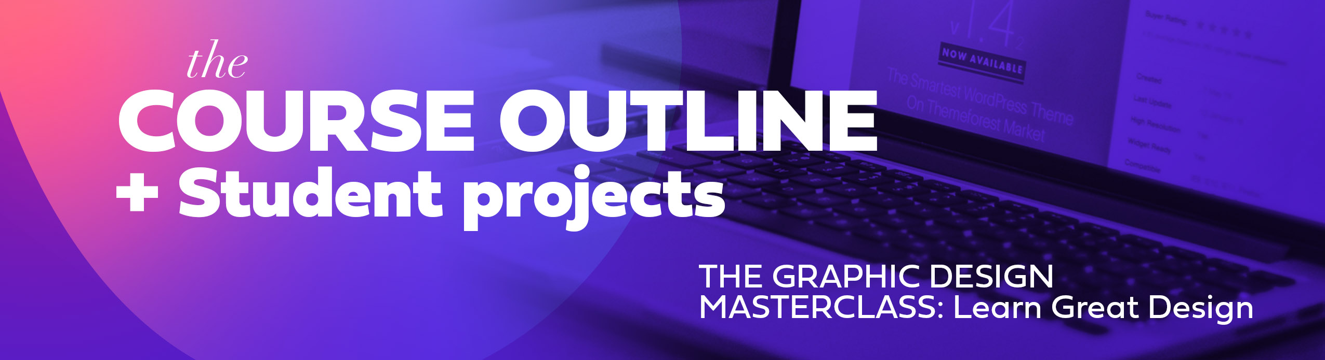

**This document gives you a course breakdown and gives you a basic outline of what to expect in the course including when to expect student projects, sections and when you can skip ahead to certain sections.   
 *Also, make sure to check out the Resources Guide PDF that contains several pages full of helpful resources for graphic designers! Also, if you want to be able to download some of the photos I used throughout the course in various lessons please check out the Photo Links resource to find links to all of the photos from Pexels.com.   
  
You can find the above referenced files in the “Course Resources Guide” folder in the downloadable .ZIP file that can be downloaded at the start of the course in the course guide lesson.***

***Course Introduction Section*That is the section you are in now.** Make sure to download any other documents in this section including the resource guide and photo links document. The course guide video is helpful in giving you a visual based walkthrough of what to expect in the course.



***Graphic Design Theory*We are going to cover a wide variety of graphic design theory topics.** I have some students ask me why do we cover so much theory before we actually start learning “how” to create something in software? I find that a basis in theory, BEFORE hoping into the software, gives you a head start when working on projects because you will already have that basic foundation in strong design theory.   
  
Take this section at your own pace. **Do not feel you have to watch the ENTIRE theory section** before starting to dip your toes into the first Photoshop section.   
  
**We will cover:**

Typography Basics  
Color Theory  
Layout Theory

Basic Grids

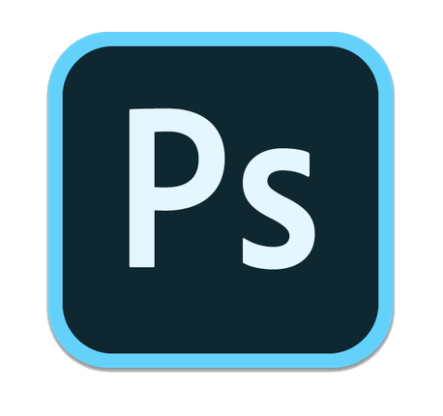

***Adobe Photoshop Introduction and Tools***

**This section is for those wanting to start at the very beginning stage learning Photoshop.** We will learn the basic layout, tools and a bit of photo editing basics.

**Things we cover in this section:**   
Basic Photoshop Setup (we will create a super quick social media graphic)  
Using and learning the Basic Tools

Duotones and Gradients   
The many options you have to cut out and isolate objects  
The Content Aware Tool  
Spot healing brush tool   
Layering Masks

***Photoshop Editing and Manipulation -*** *Intermediate Skills*

We go a little bit deeper with how to cut out and isolate objects, use the liquify tool and change colors on objects.   
  
**Things we cover in this section:**   
Changing Hair Color  
Changing Object Color

Non-destructive editing   
Advanced Editing

***STUDENT PROJECT -*** *YouTube Thumbnail*

This section goes over the creation of a simple YouTube Thumbnail in Adobe Photoshop. Your task is to create your very own YouTube thumbnail using some of the tasks we learned in previous sections: including using layering masks, working with the type tool and more. Try to keep your thumbnail simple without using too much text.

***STUDENT PROJECT -*** *A Full Book Cover Design*

This section goes over the creation of a book cover design and layout in Adobe Photoshop. Your task is to create your very own book cover using some of the tasks we learned in previous sections. You can decide to use the same concept in this section or create your very own book idea.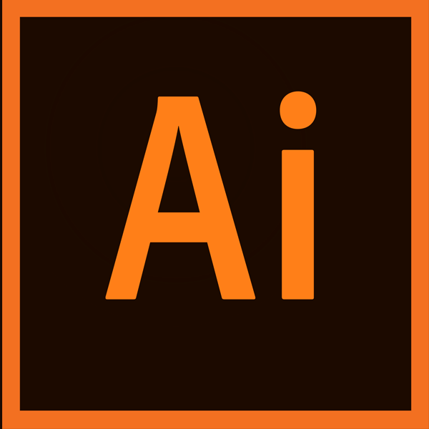

***Adobe Illustrator Introduction and Basic Tools -*** *The Tracing Worksheet*

This section is the beginner level section for Adobe illustrator. We will be working through a tracing worksheet to learn the following:   
  
**Things we cover in this section:**   
Creating simple vector shapes

Creating complex vector shapes  
Mastering the Pen Tool  
The shapebuilder tool   
Offset path  
Using grids  
  
***STUDENT PROJECT*** *- Create a vector illustration*

Inside this beginner Adobe Illustrator training section we will walk through the creation of a burger and drink vector graphic. Your task is to work through the lessons to create your own version of this graphic to practice all of our newly learned vector creation skills.   
  
**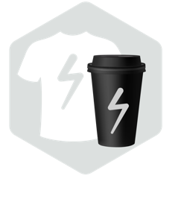  
*Logo Design & Branding Theory***

Logo design is such a big part of being a graphic designer. This section will cover some very basic logo design theory.

***Logo Design & Branding Project***

We will work through the logo creation and branding process for a made up company. We will create a logo and matching letterhead and business card.   
  
***STUDENT PROJECT -*** *Pick between a few logo design projects*

After moving through the logo design sections you will be tasked to pick one of the two logo design projects in this section. You can watch the videos in this section to get a client brief and general project direction.  
  
**1.) Create your Own Personal Logo and Brand  
2.) Create A Logo for A High-End Gym**

***Layout Practice - Event Flyer Design***

This section will be a project walkthrough where I work through the creation of an event flyer/poster in Adobe Illustrator. We talk a lot about headlines, type hierarchy and best layout practices. 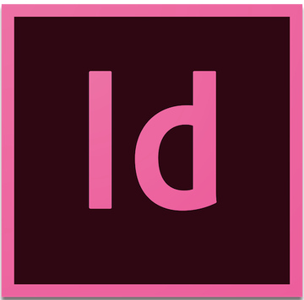

***Adobe InDesign:*** *Basic Training Section*

This section will teach you InDesign from scratch as we work on several different mini projects like an editorial spread and more.   
  
**Things we cover in this section:**   
The basics of InDesign

Working with type and paragraph tools

Master Pages   
Editorial Layout  
Working with spreads  
Character and Paragraph Styles  
Color Palettes   
  
  
***STUDENT PROJECT -*** *Create a Cookbook*

After the basic training section we dive into a full cookbook design project. I want you to create your own version. Create a cookbook that includes any style of recipes and have a little fun with this! I want you to practice using master pages to create at least several spreads. Practice exporting your files in both a print version and a digital version. Lessons in the course will guide you through this entire process.

***STUDENT PROJECT SECTION -*** *More optional student projects*

I have included even more practice project ideas. Of course **these are optional,** take them at your own pace.

***Extra Sections -*** *Take at anytime!!!*

I have included some great content at the end of this course that **can be taken ANYTIME** as you move throughout the course as they are not software dependent (with the exception of some of the design trends portions)

***Finding Your Design Niche or FOCUS***

**Do you want to become a graphic designer or get into the creative industry? Do you want to find out what design niche you should concentrate on?** This is an exploratory section that helps you find your next focus and explore many wonderful options for budding and established designers.

We are going to review some main core design categories and talk about what types of projects you will do and also what you will need to learn to leap into those design niches.   
  
Logo Design  
Print & Editorial Design  
Pattern Design and Illustration  
Package Design  
Branding Design  
UX/UI Design  
Social Media/Digital Graphic Designer

***Design Trends***

We will go over some of the emerging design trends in graphic design and also learn how to create them in software.